## **Book Review: *Thank You for Being Late***

### **1. Introduction**

#### **a. Introduction to the Author**

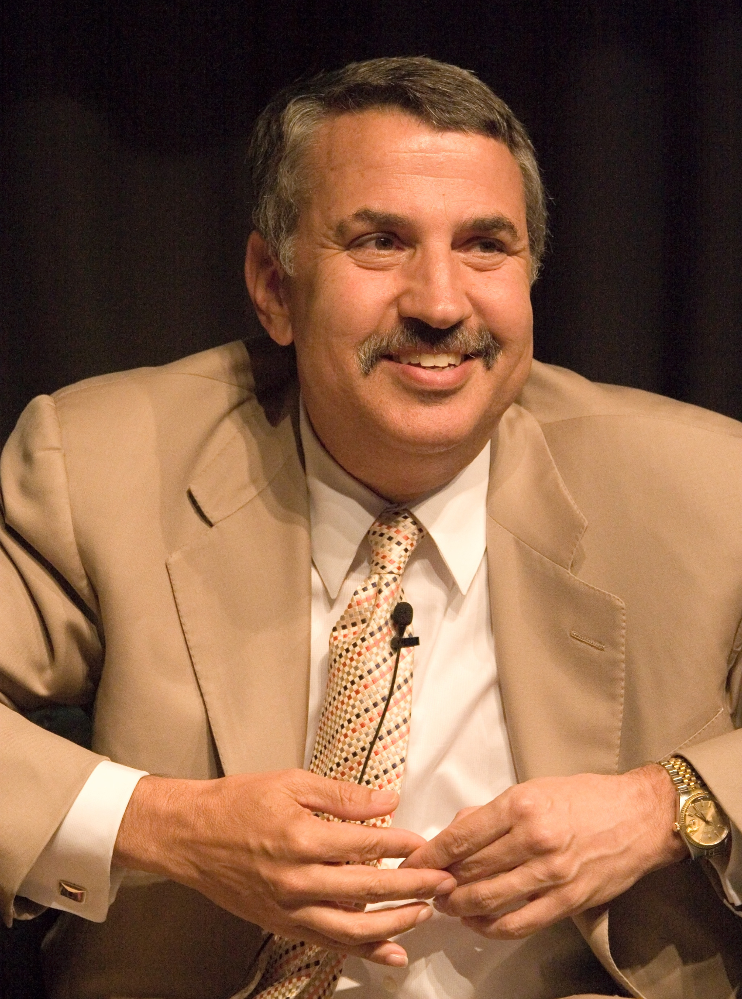

Thomas L. Friedman is a highly respected American journalist, author, and longtime columnist for *The New York Times*, renowned for his expertise in globalization, technology, and foreign affairs. Over his extensive career, he has provided in-depth analysis of pivotal global events, from the end of the Cold War to the rise of digital economies, examining their profound effects on politics, economics, and society. His insightful commentary has earned him three Pulitzer Prizes, cementing his status as one of the most influential voices in contemporary journalism.

As a bestselling author, Friedman has explored themes of economic interconnectivity, environmental challenges, and the transformative power of innovation in books such as *The World Is Flat*, *Hot, Flat, and Crowded*, and *That Used to Be Us*. His writing is distinguished by its analytical depth and engaging narrative style, making complex topics like artificial intelligence, climate change, and globalization accessible to a wide audience. He skillfully distills vast amounts of information into clear, thought-provoking arguments, influencing policymakers, business leaders, and everyday readers.

A strong advocate for adaptability and lifelong learning, Friedman emphasizes the need to embrace change rather than resist it. His optimistic yet pragmatic perspective highlights how individuals and societies can navigate and thrive in an era of rapid technological and economic transformation.

#### **b. Introduction to the Book**

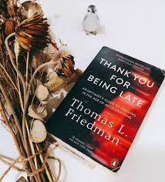

*Thank You for Being Late* by Thomas L. Friedman explores the rapid technological, economic, and societal changes shaping the 21st century. As a Pulitzer Prize-winning journalist, Friedman blends personal stories, historical insights, and expert perspectives to highlight how moments of pause—like waiting for a late appointment—offer valuable time for reflection.

The book is divided into four parts—Reflection, Acceleration, Innovation, and Anchoring—examining fast-paced advancements since 2007, the rise of AI, and the impact of globalization and climate change. Friedman stresses the need for lifelong learning, adaptability, and human connection in a rapidly evolving world.

With a mix of storytelling and analysis, the book acts as both a guide and a call to action, urging readers to reflect deeply and adapt wisely to thrive amid constant change.

### **2. Summary of the Book**

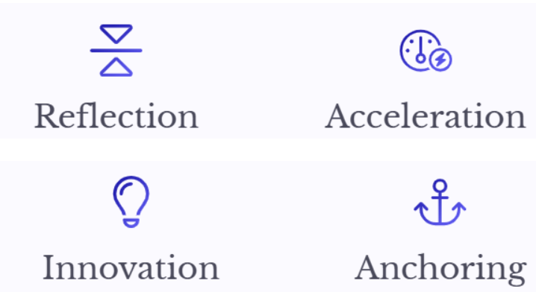

The book is divided into four key sections:

1. **Reflecting** – Friedman opens by stressing the importance of slowing down to understand the rapid changes shaping our world. A chance encounter with a parking lot attendant who blogged about Ethiopian politics inspired the book’s title and message: reflection is essential for making sense of the technological and societal shifts we face today.
2. **Accelerating** – He identifies 2007 as a turning point, marking the start of an era of rapid technological change driven by innovations like the iPhone and social media. Moore’s Law and the rise of AI, globalization, and climate change are all accelerating forces. Friedman argues we must embrace “dynamic stability”—constantly adapting like riding a bike—to stay balanced in this fast-moving world.
3. **Innovating** – This section focuses on how people, businesses, and governments must adapt to automation and shifting job markets. Friedman emphasizes the value of lifelong learning, intelligent tools, and entrepreneurial thinking to stay relevant as knowledge becomes quickly outdated.
4. **Anchoring** – Using his hometown of St. Louis Park as an example, Friedman highlights the power of strong communities, trust, and shared values to provide stability amid change. He explores how scalable behavior, diversity, and adaptable institutions are key to navigating the global impacts of technology and climate change.

Friedman ends on a hopeful note, encouraging ethical leadership, collaboration, and proactive adaptation as tools for turning rapid change into shared progress. He believes that with education and connectivity, individuals can help shape a better, more resilient future.

### **3. Review of the Book**



**Strengths**

1. **Clear Explanations**
   * Friedman effectively breaks down complex concepts. For example, he simplifies Moore’s Law by referencing Intel co-founder Gordon Moore’s observation that computing power doubles roughly every two years, using it to illustrate the exponential growth of AI and automation.
   * He also explains globalization through the idea of *Globalization 3.0*, highlighting how global connectivity has shifted from being driven by nations and corporations to being powered by individuals.
2. **Engaging Storytelling**
   * Personal anecdotes add depth and relatability. His experience writing part of the book at an Ethiopian restaurant introduces the idea of "pausing" in a fast-paced world.
   * Interviews, like the one with former Intel CEO Brian Krzanich, illustrate how advances in chip technology affect almost every aspect of modern life, making complex technological shifts more tangible.
3. **Optimistic Outlook**
   * Rather than portraying job automation as a threat, Friedman focuses on the emergence of “STEMpathy” jobs—roles that combine technical skills with human empathy—as a growing opportunity.
   * He emphasizes lifelong learning, citing examples like AT&T, which encourages employees to reskill continually to remain relevant in a rapidly changing job market.
4. **Comprehensive Analysis**
   * Friedman examines the intersection of technology, economics, and the environment. He discusses how extreme weather events linked to climate change can disrupt global food supply chains.
   * He also shows how industries evolve with technology and market forces, using Airbnb and Uber as examples of companies born from advancements in AI and smartphones.

**Weaknesses**

1. **Dense Information**
   * While insightful, Friedman’s deep dives—such as the Cold War’s influence on technological progress—may slow the pace for readers seeking a more casual or fast-paced narrative.
   * His exploration of automation and job displacement includes detailed economic data that might feel overwhelming for readers less familiar with the subject.
2. **Repetitiveness**
   * The theme of acceleration is emphasized repeatedly across chapters, through discussions on AI, globalization, and climate change. While reinforcing the book’s message, this repetition can feel excessive.
   * Similarly, the emphasis on lifelong learning and adaptability is illustrated through multiple case studies, which, although relevant, sometimes reiterate the same core ideas.

### **4. My Reading Experience**

*Thank You for Being Late* was both insightful and thought-provoking, offering a deep reflection on how rapidly evolving technology shapes daily life and global interconnectedness. One of the most striking takeaways was the necessity of continuous learning—remaining stagnant is simply not an option in a world that never stops changing.

Friedman’s exploration of the role communities play in maintaining stability amid transformation stood out, providing a refreshing counterpoint to the typical focus on technological advancement. His emphasis on ethics and human relationships added depth to the discussion, making it more than just a book about innovation.

Although some sections were more technical, Friedman’s engaging journalistic style and real-life examples kept the narrative compelling. His ability to link historical events to modern technological shifts was particularly impressive, demonstrating how past innovations have paved the way for today’s accelerated change.

The book’s discussion on *dynamic stability*—the idea that continuous adaptation is essential for survival—was especially thought-provoking. By not only highlighting global challenges but also offering a roadmap for resilience, *Thank You for Being Late* serves as a valuable guide for anyone seeking to navigate today’s fast-changing world.

### **Introduction to *Sapiens: A Brief History of Humankind***

#### **a. Introduction to the Author**



Yuval Noah Harari is an Israeli historian, professor, and bestselling author known for making complex historical, philosophical, and scientific ideas accessible and engaging. He teaches at the Hebrew University of Jerusalem and has earned international acclaim for turning extensive research into compelling narratives.

His books—*Sapiens: A Brief History of Humankind*, *Homo Deus: A Brief History of Tomorrow*, and *21 Lessons for the 21st Century*—explore the evolution of human civilization, the role of technology and economics, and the uncertainties of the future. Harari goes beyond traditional history, examining how artificial intelligence, biotechnology, and the future of work are set to reshape human society.

Celebrated for making history relevant to today’s world, Harari blends historical analysis with science and philosophy. His thought-provoking insights have reached global audiences through TED Talks and interviews, establishing him as one of the most influential thinkers of our time. More than reflecting on the past, his work serves as a guide for understanding and navigating the future.

#### **b. Introduction to the Book**

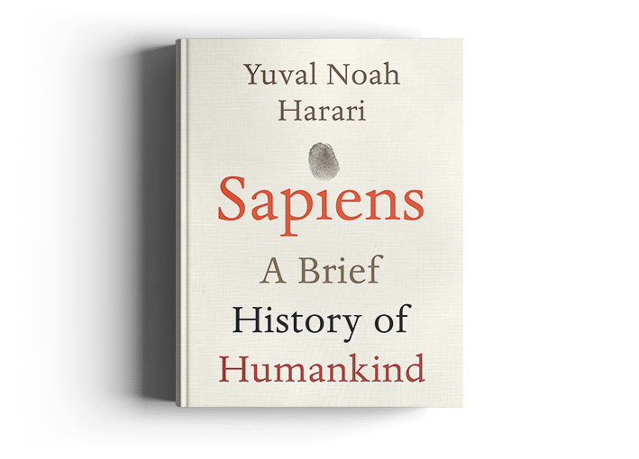

First published in Hebrew in 2011 and translated into English in 2014, *Sapiens: A Brief History of Humankind* charts the journey of Homo sapiens from the Stone Age to the modern era. Yuval Noah Harari explores how key revolutions—cognitive, agricultural, and scientific—have shaped human society and argues that much of what binds us, like money, religion, and politics, is based on shared myths and imagined realities.

Blending history, anthropology, and biology, Harari examines what sets humans apart and how our species came to dominate the planet. The book is divided into four parts: the Cognitive Revolution (our unique ability to imagine and cooperate), the Agricultural Revolution (how farming reshaped societies), the Unification of Humankind (the merging of cultures and empires), and the Scientific Revolution (the rapid progress of the last 500 years).

Harari challenges traditional historical narratives by emphasizing the role of storytelling in human development and questions whether progress has truly improved human well-being. *Sapiens* encourages readers to rethink humanity’s past, understand the present, and reflect on the direction we're headed.

### **2. Summary of the Book: *Sapiens: A Brief History of Humankind***

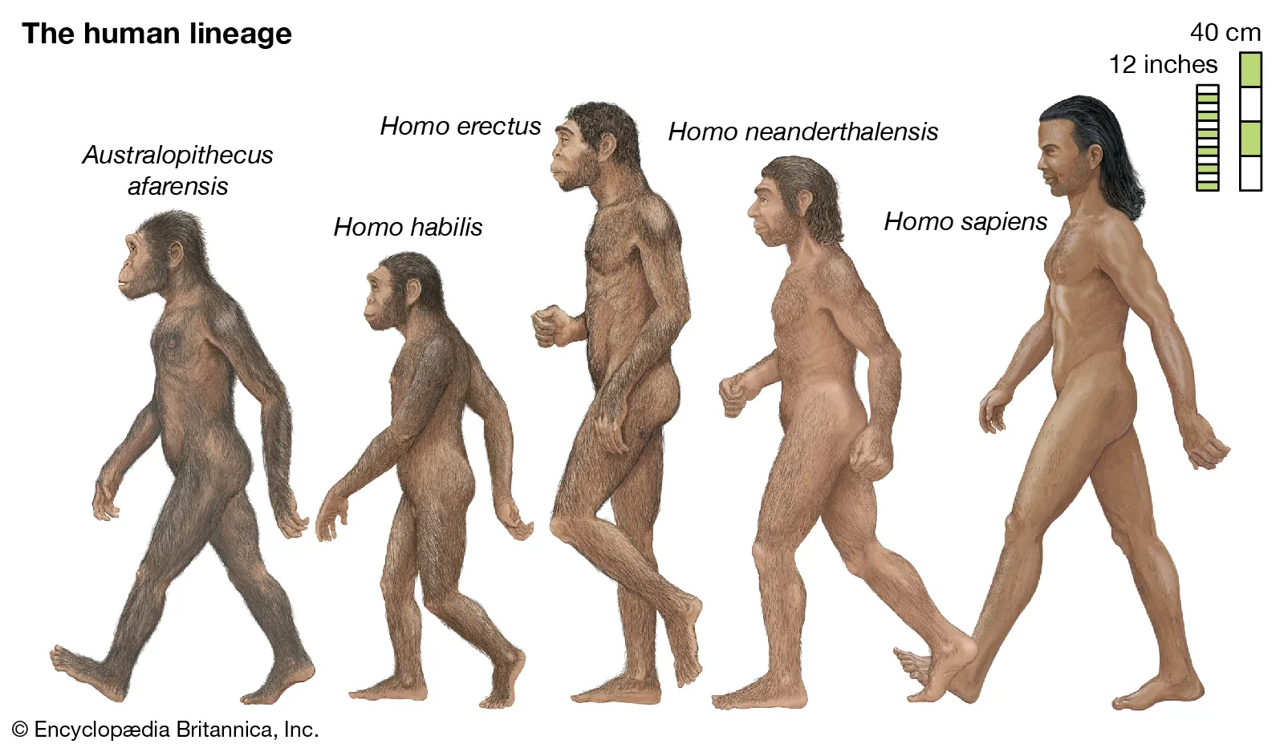

In *Sapiens: A Brief History of Humankind*, Yuval Noah Harari presents a sweeping narrative of human evolution, tracing the ascent of Homo sapiens from ordinary apes to the planet’s dominant species. The book is structured around four transformative revolutions that reshaped human civilization: the Cognitive, Agricultural, Unification, and Scientific Revolutions. Harari’s central thesis is that the unique ability of humans to believe in shared myths—such as religion, money, and political ideologies—enabled large-scale cooperation and societal development. However, he also prompts readers to question whether these developments have genuinely improved human happiness and well-being.

**1. The Cognitive Revolution (~70,000 BCE)**

* This era marked the emergence of abstract thinking, complex language, and the capacity for collective imagination.
* Harari attributes Sapiens' dominance to their capacity for storytelling—creating shared fictions like myths, religions, and social hierarchies.
* This revolution gave them a decisive advantage over other human species, including Neanderthals.

**2. The Agricultural Revolution (~10,000 BCE)**

* Farming allowed for settled communities, population growth, and the formation of complex societies.
* Harari critiques agriculture as a "luxury trap"—it increased food production but also introduced harder labor, social inequality, and decreased individual well-being compared to foraging life.

**3. The Unification of Humankind**

* Human cultures began merging through trade, conquest, and shared belief systems like religion, money, and empires.
* These “imagined orders” enabled global cooperation but also entrenched systems of control and inequality.

**4. The Scientific Revolution (~1500 CE – Present)**

* Driven by the admission of ignorance, this period launched rapid advancements in knowledge, exploration, and technology.
* Tied closely with capitalism and empire-building, it gave humanity unprecedented power but also led to colonization, consumerism, and environmental damage.

Harari ends with a thought-provoking critique of modern life, questioning whether industrial and technological progress have truly made us happier. He warns of future disruptions from AI, biotechnology, and genetic engineering—forces that may redefine humanity itself. *Sapiens* doesn’t present history as a steady march of progress but as a series of transformative shifts—each with its own costs and consequences—urging readers to rethink where we’ve come from and where we’re headed.

### **3. Review of the Book: *Sapiens: A Brief History of Humankind***

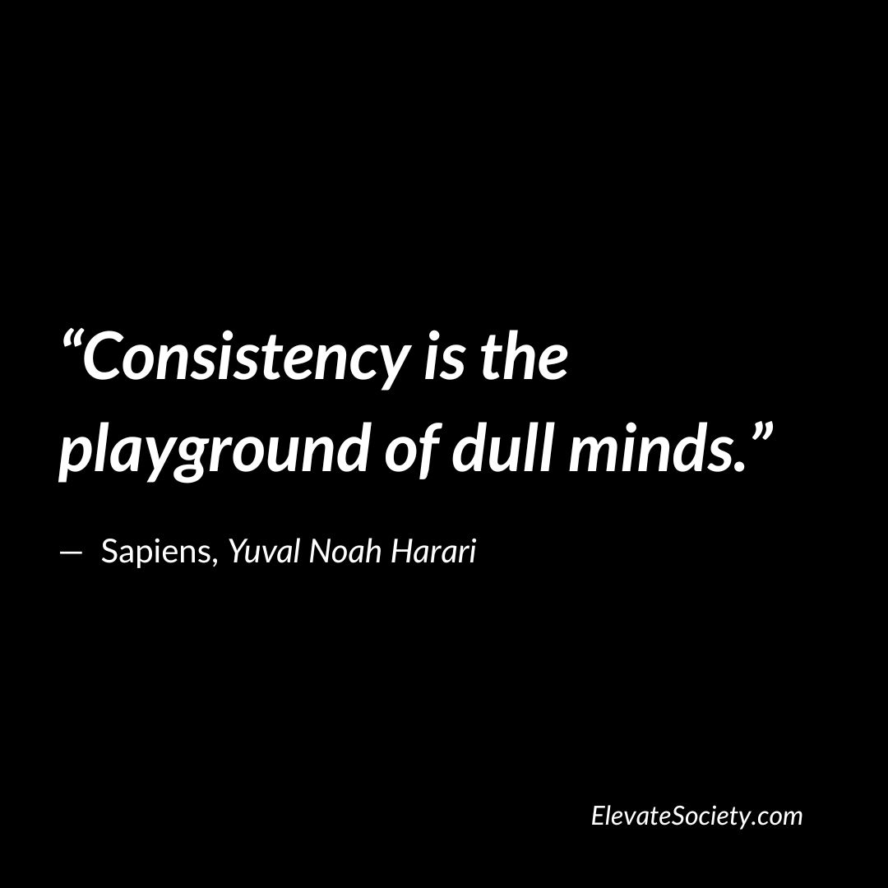

***Sapiens: A Brief History of Humankind*** *by Yuval Noah Harari is a captivating and thought-provoking book that reexamines humanity’s past through a multidisciplinary lens. Blending history, anthropology, biology, and economics, Harari explores how Homo sapiens came to dominate the world—not through physical strength, but through imagination, cooperation, and shared myths. His accessible and engaging narrative challenges traditional ideas about progress, happiness, and the future of our species.*

***Strengths***

***1. Interdisciplinary Approach***

* *Harari draws from evolutionary psychology, biology, and history to explain human dominance, particularly through the Cognitive Revolution and our ability to cooperate via shared beliefs.*
* *His analysis of economic development, especially in the chapter on money, effectively shows how abstract concepts like currency enabled large-scale trade and societal complexity.*

***2. Engaging Style***

* *Through vivid analogies (e.g., comparing belief in brands to shared myths), Harari makes complex ideas accessible.*
* *He reframes key events like the Agricultural Revolution as double-edged developments that brought both progress and problems.*

***3. Thought-Provoking Ideas***

* *The book questions whether agriculture improved human life and whether modern progress has led to greater well-being.*
* *Harari presents religion, capitalism, and nationalism as imagined realities that enable cooperation but can also reinforce inequality.*

***4. Modern Relevance***

* *Harari links historical revolutions to present-day challenges like climate change, capitalism, and AI.*
* *He warns that future technologies could widen social divides and challenge what it means to be human.*

***Weaknesses***

***1. Speculation Over Evidence***

* *Some claims, such as agriculture worsening human life, are contested and not universally accepted.*
* *His views on happiness and progress sometimes rely more on opinion than data.*

***2. Oversimplification***

* *Complex societies and historical dynamics are occasionally reduced to broad generalizations.*
* *Religion is mostly treated as myth, overlooking its cultural and emotional roles.*

***3. Lack of Personal Perspective***

* *The book focuses on collective trends rather than individual experiences, giving little attention to emotions, relationships, or personal lives.*

### **4. My Reading Experience**

*Reading Sapiens: A Brief History of Humankind was both enlightening and thought-provoking.* Harari’s engaging storytelling made complex historical and philosophical ideas feel accessible. The book challenged many of my assumptions about human progress—especially the idea that money, religion, and nations are shared myths sustained by collective belief.

The Cognitive Revolution stood out most, revealing how Homo sapiens rose through imagination and cooperation. Harari’s view of the Agricultural Revolution as a “trap” was eye-opening, and his insights into the Scientific Revolution and modern capitalism felt especially relevant, showing how technology and economics continue to shape our lives.

Though occasionally dense, the book’s thought-provoking ideas kept me engaged. Harari’s questioning of whether progress truly brings happiness made me reflect on how we define success today.

Sapiens is more than a history book—it’s a compelling lens on humanity’s past, present, and future. I’d highly recommend it to anyone interested in human nature or the forces shaping our world.